

LICENSURE EXAMINATION FOR PROFESSIONAL TEACHERS
SEPTEMBER 20, 2026

GURONG PINOY: GENERAL EDUCATION REVIEWER
MATHEMATICS REFRESHER
(Session 5: May 08, 2026)

1. In Roman numerals, what letter in the alphabet represents 1,000?
- M
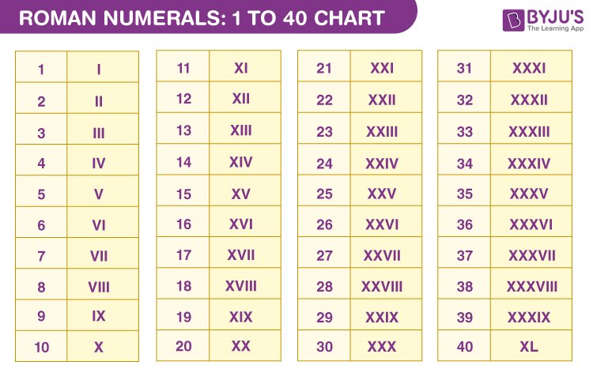
- L
- D
- C

Solution:

2. The value of the expression 3xy + 3y + 7 when x = 2 and y = 3 is:
- 36
- 42
- 34
- 40

Solution:

3. A box holds 222 apples. How many apples are there in 20 boxes?
- 4400
- 4440
- 4420
- 4460

Solution:

4. What is the amount due on P 12,000.00 after adding the annual interest of 8% for 3 years?
- P14, 880.00
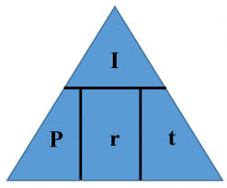
- P16, 800.00
- P15, 880.00
- P15, 800.00

Solution:

5. If the student has an average of 76% on his first two tests and has an average of 85% on the next 4 tests, what is the final average?
- 82.0%
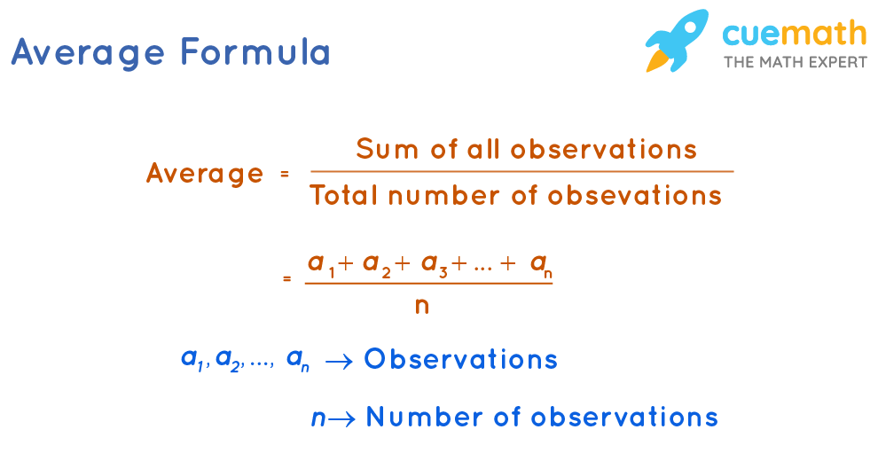
- 81.3%
- 82.59%
- 82.5%

Solution:

6. What is the coefficient in the expression 18x³y³?
- 18
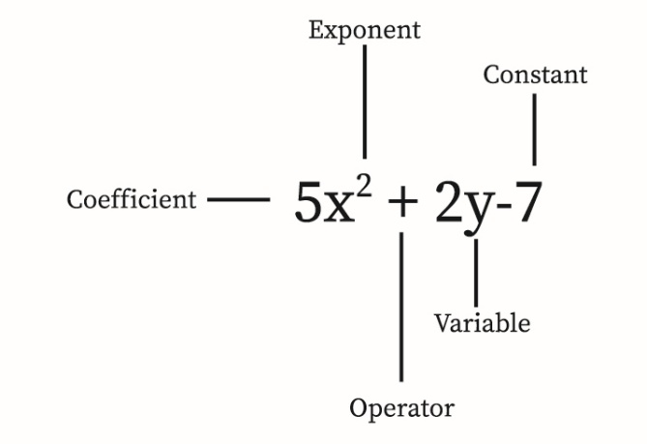
- X
- 3
- 1

Solution:

7. Simplify: (2y²+4y-5xy) + (8xy+2y²+3y)
- 4y²+7y+3xy
- -4y²+2y-3xy
- 4y²-7y-3xy
- 4y²-7y+3xy

Solution:

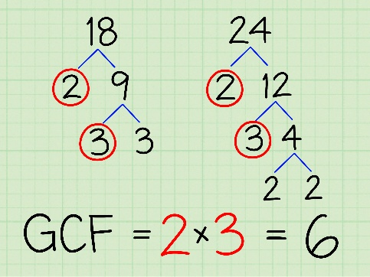
8. The greatest common factor of 52 and 104 is ___
- 9
- 13
- 11
- 7

Solution:

9. Find the amount due at the end of 2 ½ years if P 8,000.00 is invested at 12% simple interest.

- P10,400.00
- P12, 400.00
- P14,800.00
- P13,800.00

Solution:

10. Simplify: (2x-3y) + (y-4z) – (z-3x)
- 5x+2y-5z
- -5x+2y+5z
- 5x+2y+5z
- 5x-2y-5z

Solution:

11. How much was borrowed if the interest at 8% is P6,000 after 3 months is 76,000.00?
- P25,000.00
- P300,000.00

- P150,000.00
- P200,000.00

Solution:

12. What is the amount due on P10,000.00 after adding the annual interest of 8% for 3 years?

- P 13,400.00
- P 11,800.00
- P 12,400.00
- P 15,800.00

Solution:

13. The simple interest on P20,000.00 for 3 years at 9% annually is ___

- P 6,200.00
- P 5,400.00
- P 6,800.00
- P 4,800.00

Solution:

14. Vivian obtained the following results from her Mathematics examinations: 90, 83, 82, 85. What score must she get on the next examination so that her average score is 86?
- 84
- 89
- 90
- 93

Solution:

15. How long will it take A and B together, to finish a job which can be done by A alone in 6 days and B alone in 3 days?
- 2 1/2 days
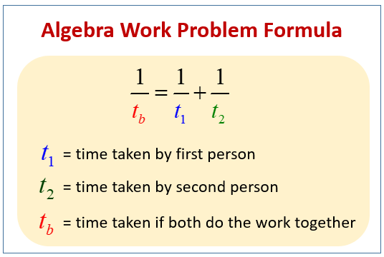
- 2 days
- 3 days
- 3 ½ days

Solution:

16. Tom and Bob have a total of 49 toys. If Bob has 5 more toys than Tom, how many toys does Tom has?
- 22
- 27
- 23
- 26

Solution:

17. The fraction halfway between 3/7 and 4/7 is ______________.
- 1/2
- 1/3
- 1/4
- 1/8

Solution:

18. In a certain school, the ratio of boys to girls is 5 is to 7. If there are 180 boys and girls in the school, how many boys are there?
- 105
- 90
- 45
- 75

Solution:

19. A number is divided by 5. The result was subtracted by 154, and the difference is 6. What is the number?
- 800
- 160
- 200
- 400

Solution:

20. Joey gathered twice more marbles than Vic, and Tito gathered two more marbles than Vic. They gathered 26 marbles. How many marbles did Vic gather?
- 6
- 12
- 8
- 14

Solution:

21. In an English test, eight students obtained the following scores: 10, 15, 12, 18, 16, 24, 12, 14. What is the median score?
- 14
- 14.5
- 15.5
- 15

Solution:

22. Find the least common multiple of 5, 2, 7
- 35
- 140
- 15
- 70

Solution:

23. A Toyota car travelling at a rate of 70 km per hour leaves the house 2 hours after a Kia car has left and overtakes it in 5 hours at what rate was the Kia car travelling?
- 30 kilometers per hour
- 50 kilometers per hour
- 20 kilometers per hour
- 40 kilometers per hour

Solution:

24. If the average or arithmetic mean of x and -5 is 10, then what must be the value of x?
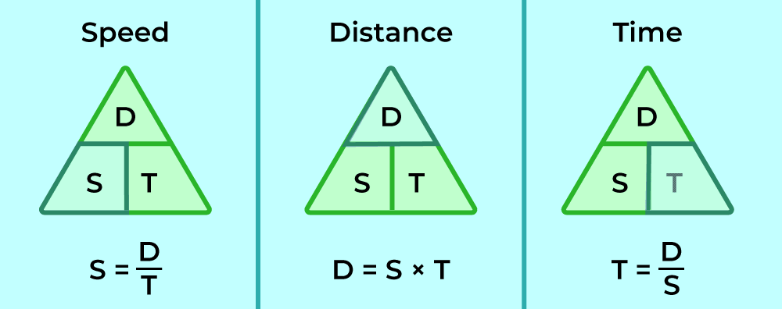
- 15
- 25
- 30
- 20

Solution:

25. What is the identity 𝑠𝑖𝑛𝜃 over 𝑐𝑜𝑠𝜃 ?
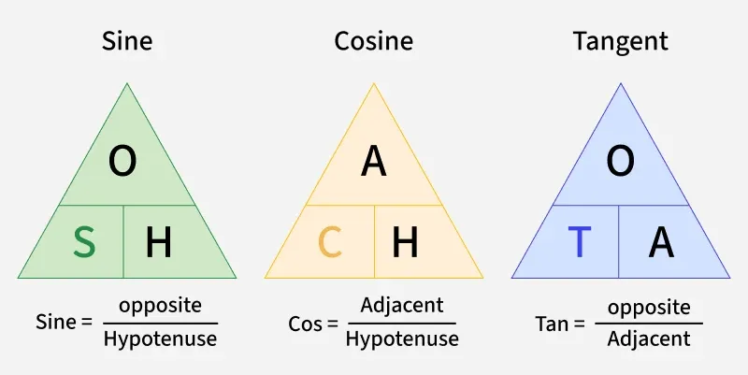
- tan𝜃
- cos𝜃
- csc𝜃
- sec𝜃

Solution:

